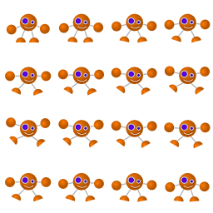

**Congratulations!**

**You’ve succeeded through all labyrinths**

**and helped Zero to reach his home.**

**You are a great player!**

**See you soon!**

**A game made by Dimitar Katsarski**

